**CREATING IBM CLOUD SERVICE**

|  |  |
| --- | --- |
| **Date** | 26 OCTOBER 2022 |
| **Team ID** | PNT2022TMID17620 |
| **Project Name** | GAS LEAKAGE MONITORING AND ALERTING SYSTEM FOR INDUSTRIES |

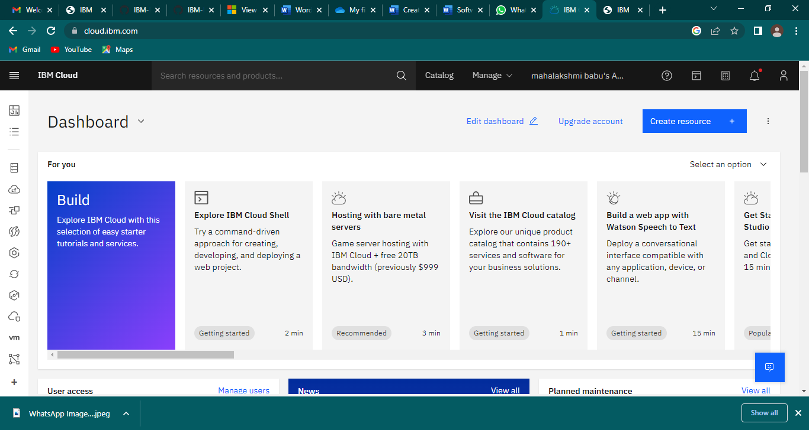

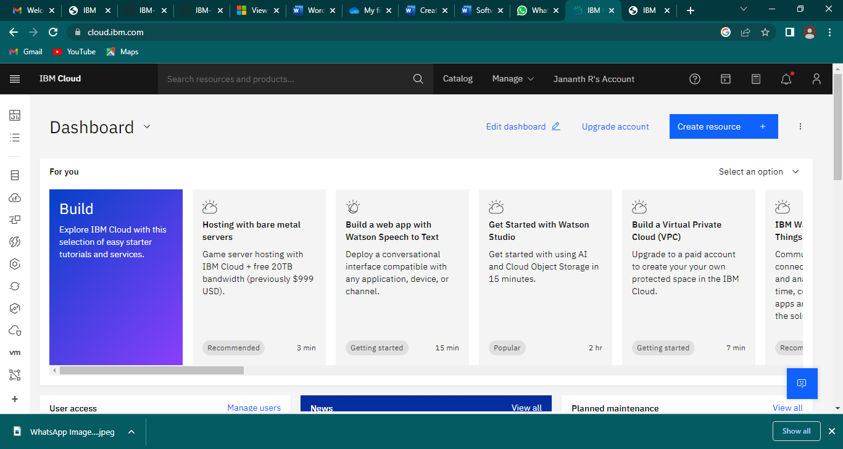

An IBM Cloud Service created Successfully .